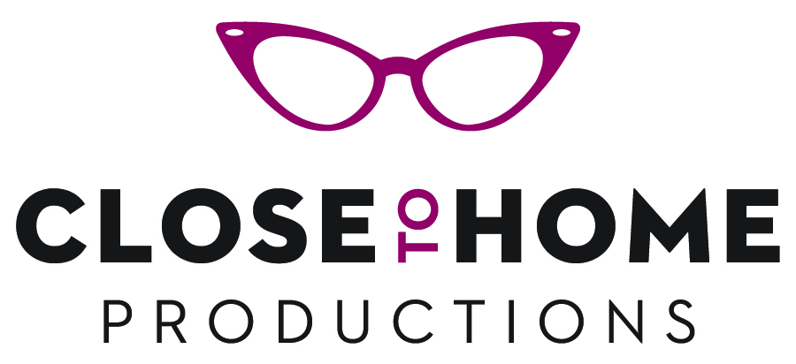

PO Box 442 Ithaca, NY 14851-0442 | info@CloseToHomeProductions.com

Stay Strong: Lift for Life

Order form

Check or money order only made out to ‘CloseToHome Productions’.
Items will be shipped within 5 to 7 days of receiving your order.

Name:

Agency or organization:

Street:

City: State: Zip Code:

Phone: Fax:

Email:

Item | Price | Quantity | Total
Stay Strong: Lift for Life DVD | $9.95 |  | $
NY State sales tax (NY State residents only enter tax)
Shipping and handling DVD ( please enter $4) for each item ordered. | $6.25 each |  | $

Total | $

This is a gift, please ship to:

Name:

Agency or organization:

Street:

City: State: Zip Code:

